

Indoor Plants

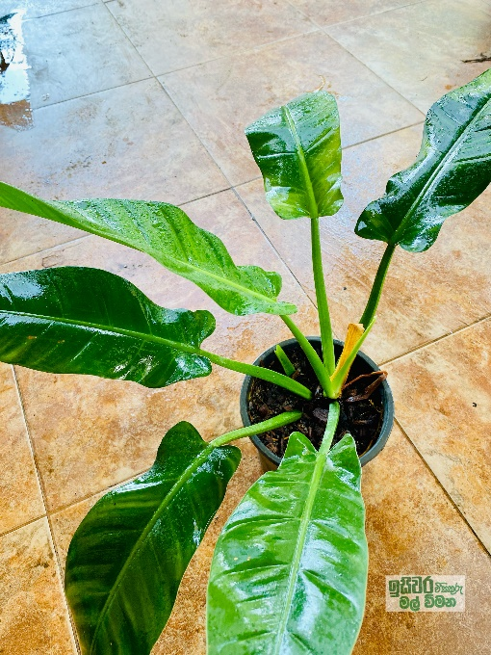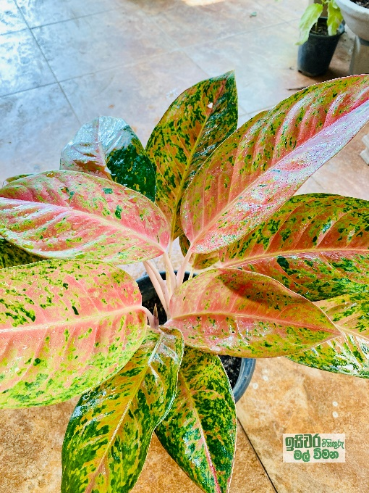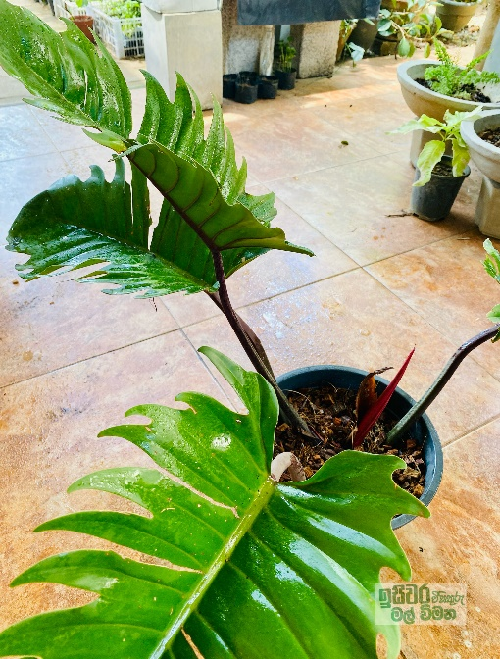

Name: Aglonima

Price: Rs. 1500/-

Name: Pillow

Price: Rs. 2500/-

Name: Pillow

Price: Rs. 3500/-

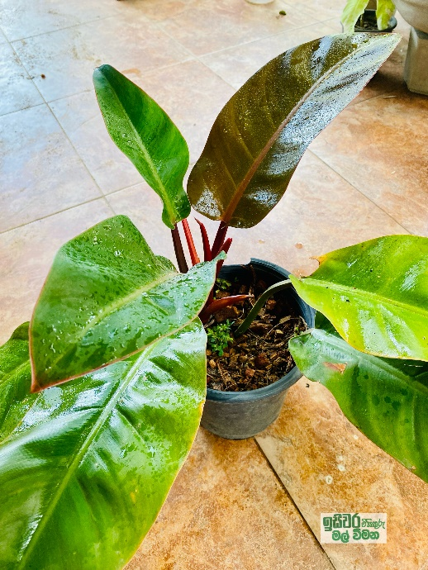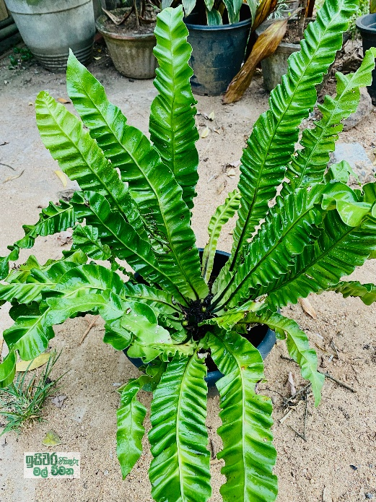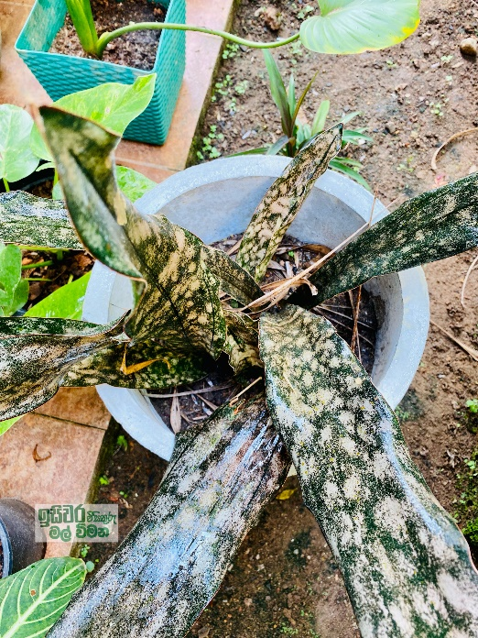

Name: Furne (Shipper)

Price: Rs. 3000/-

Name: Pillow

Price: Rs. 3000/-

Name: Sansaveria

Price: Rs. 2000/-

Name:

Price:

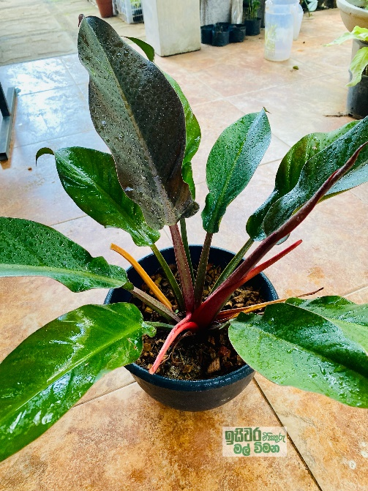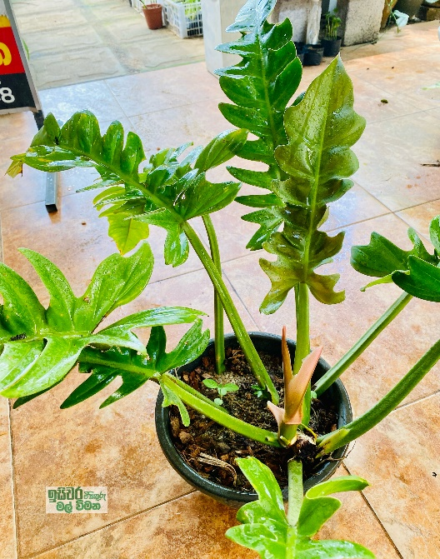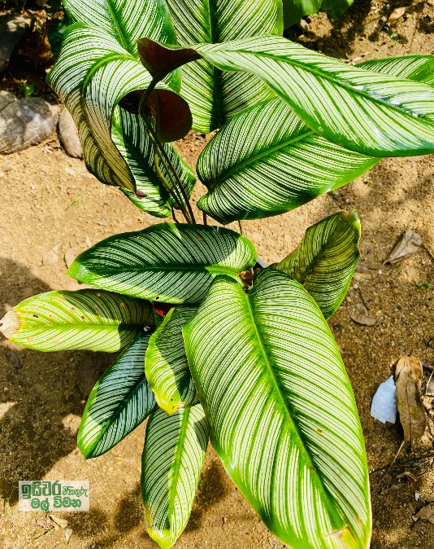

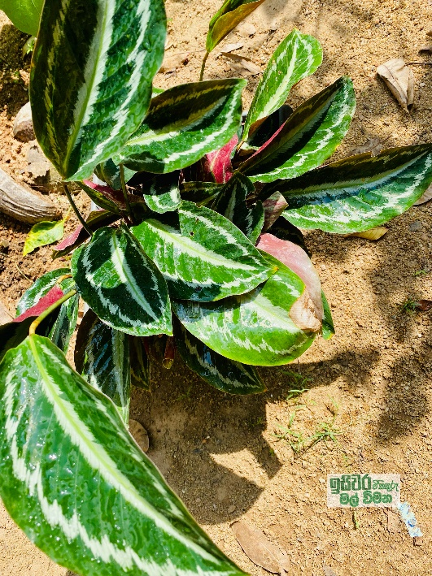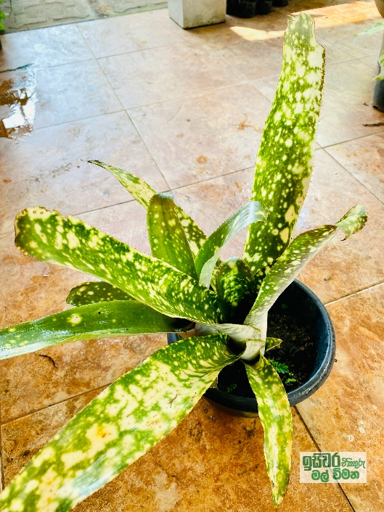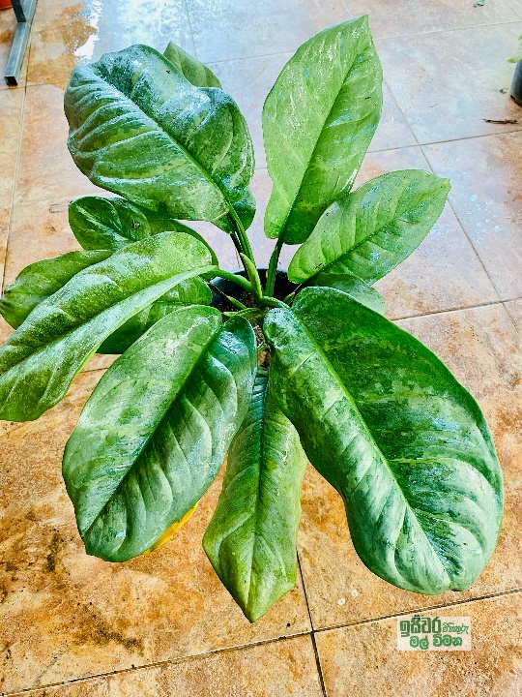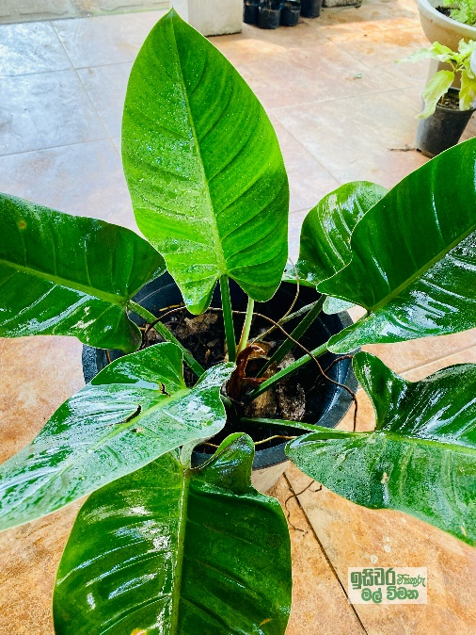

Name: Pillow (Green Cardinal)

Price: Rs.2500/-

Name: Aglonima

Price: Rs.1000/-

Name: Bomolia

Price: Rs.2000/-

Name: Calathiya

Price: Rs. 1000/-

Name: Pillow

Price: Rs. 3500/-

Name: Pillow (Crocadile)

Price: Rs. 1700/-

Name: Calathiya

Price: Rs. 1600/-

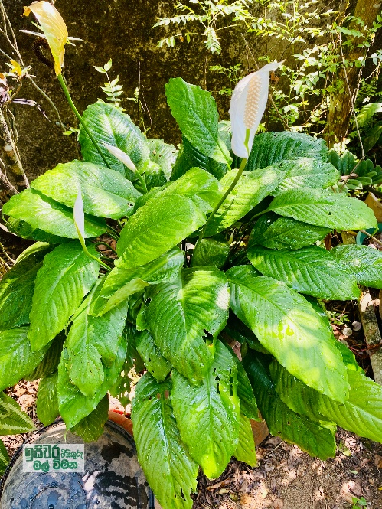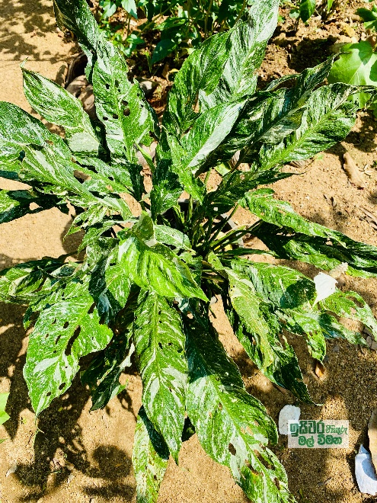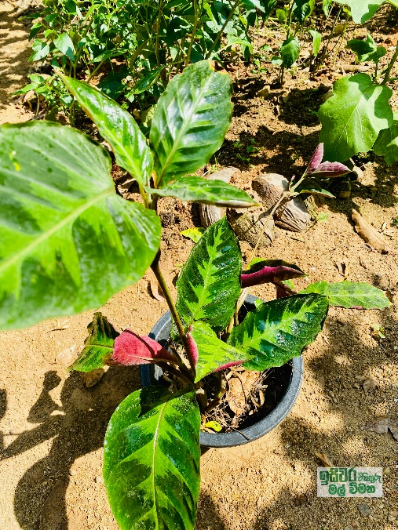

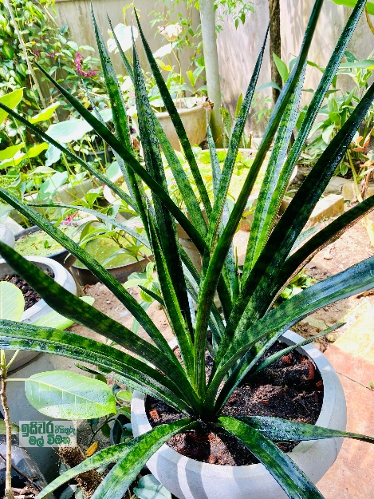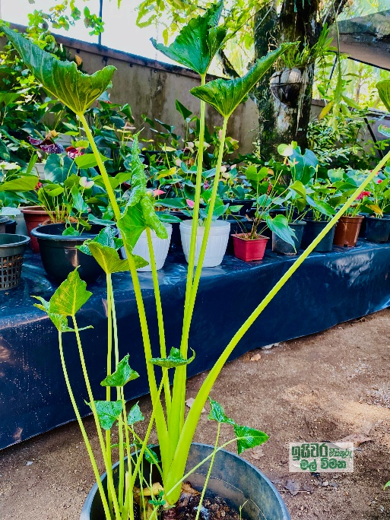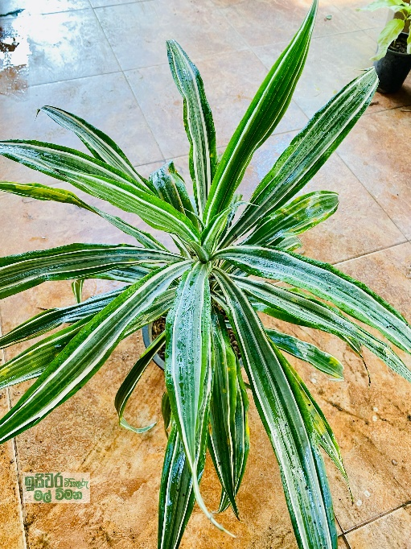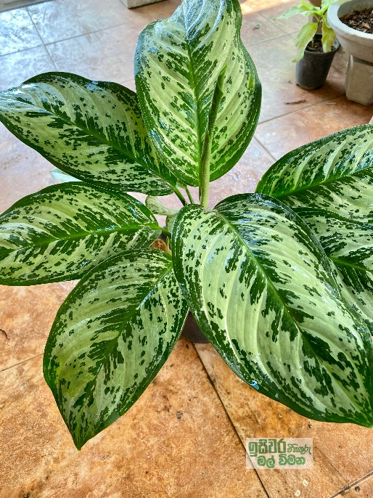

Name: Sansaveria

Price: Rs.4000/-

Name: Aglonima

Price: Rs.750/-

Name: Code-line

Price: Rs.750/-

Name: Caladium

Price: Rs.750/-

Name: Peace Lily

Price: Rs.2000/-

Name: Peace Lily

Price: Rs.1200/-

Name: Calathiya

Price: Rs.750/-

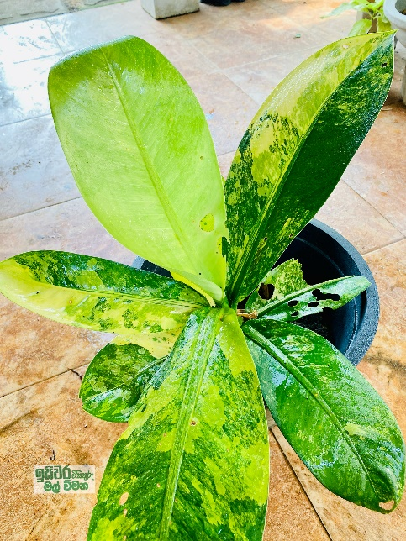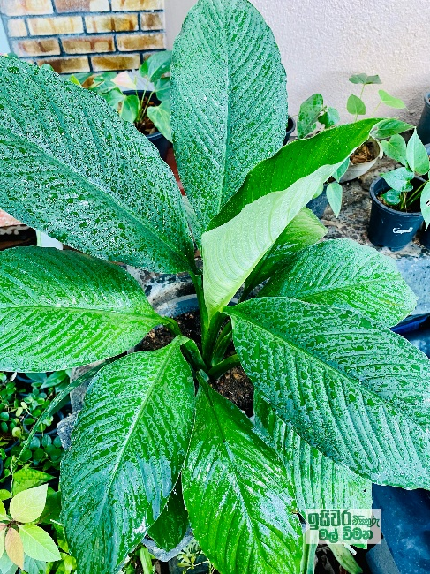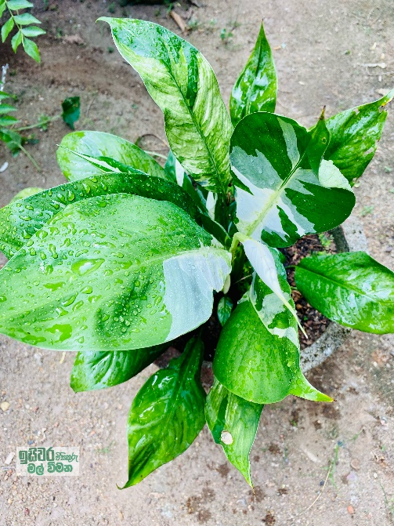

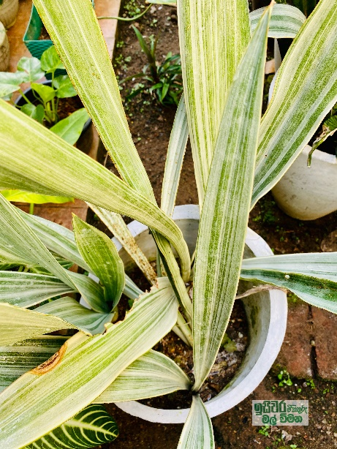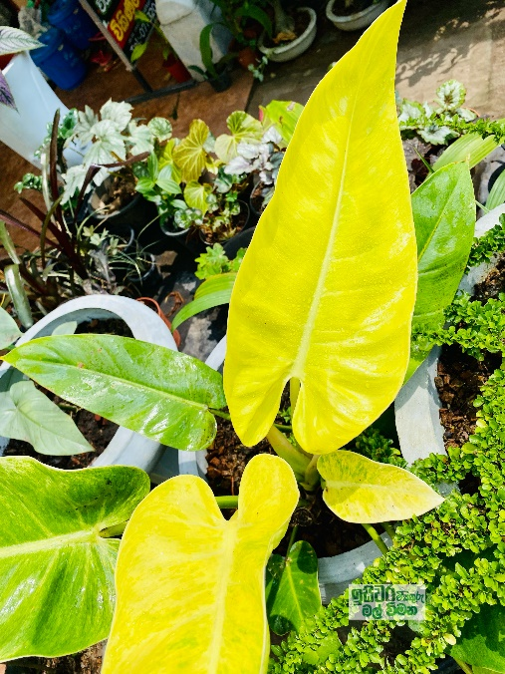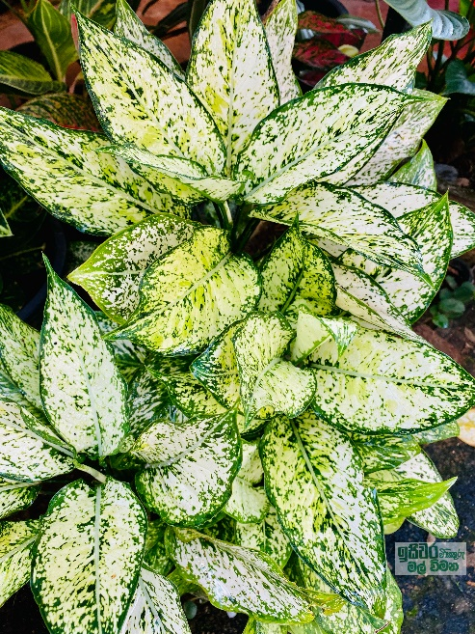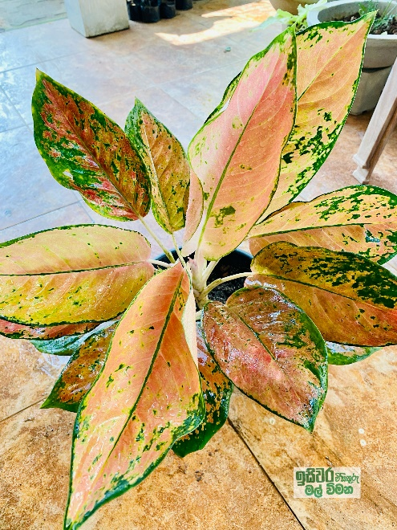

Name: Pillow (Yellow Cardinal)

Price: Rs.2500/-

Name: Peace Lily Variegate

Price: Rs.2000/-

Name: Pillow

Price: Rs.3500/-

Name: Pillow

Price: Rs.2500/-

Name: Aglonima

Price: Rs.2500/-

Name: Aglonima

Price: Rs.2000/-

Name: Sansaveria

Price: Rs.2000/-

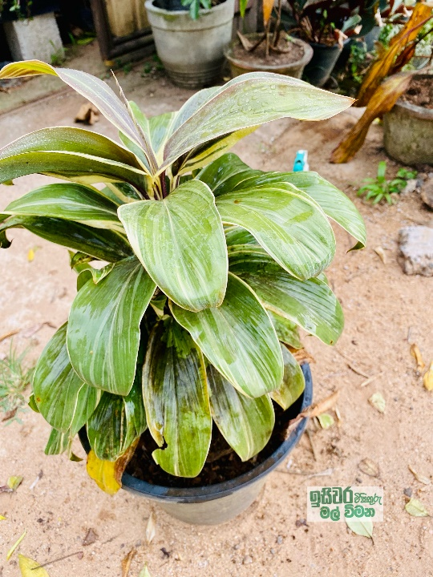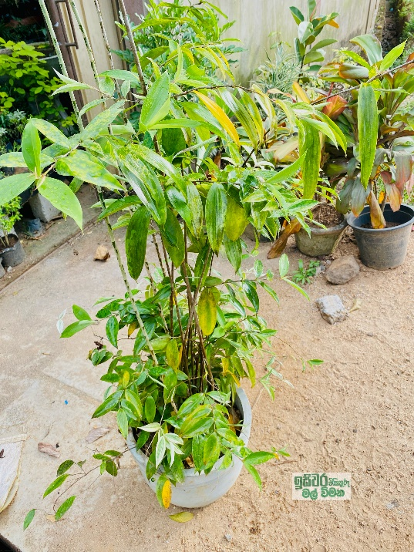

Outdoor Plants

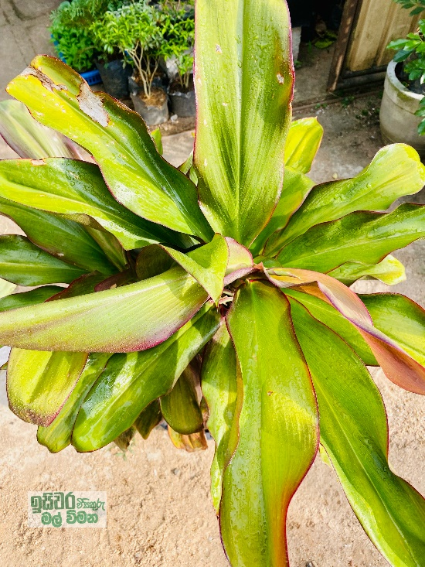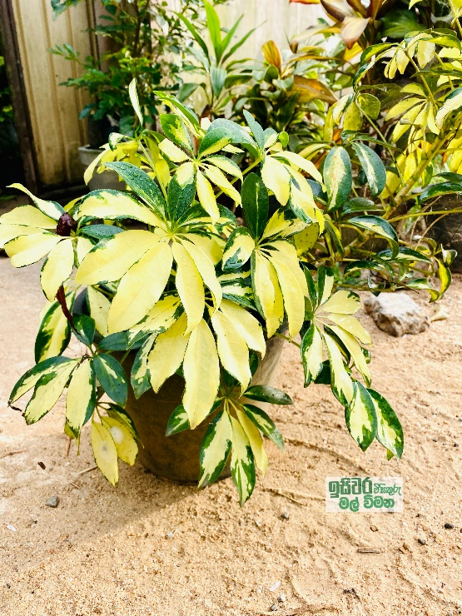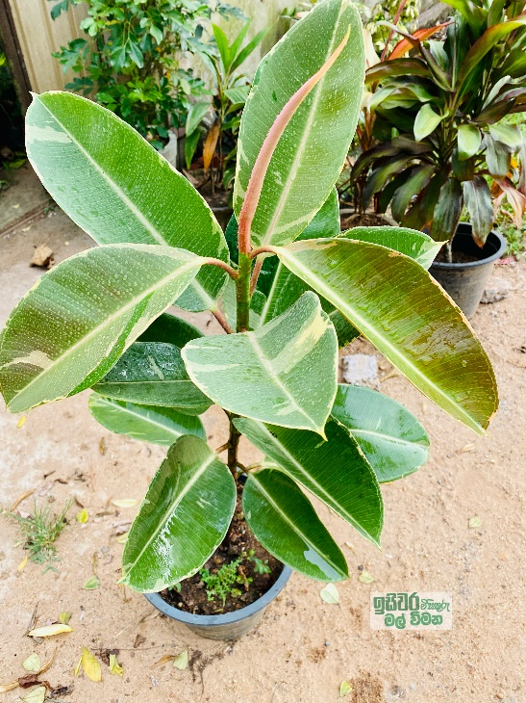

Name: Rubber pot Variegate

Price: Rs.1800/-

Name: Rubber Plant

Price: Rs.1500/-

Name: Code-line

Price: Rs.750/-

Price: Rs.700/-

Name: Code-line

Price: Rs.1000/-

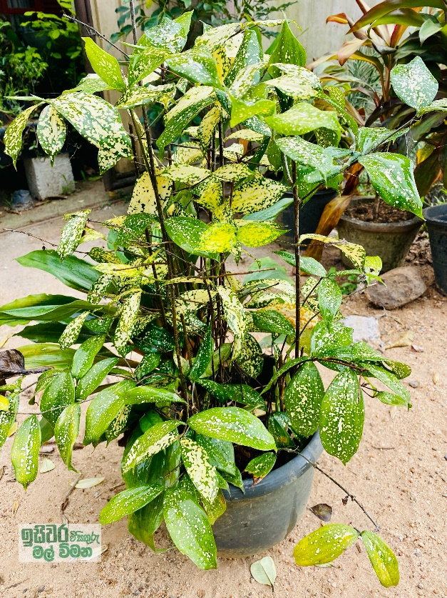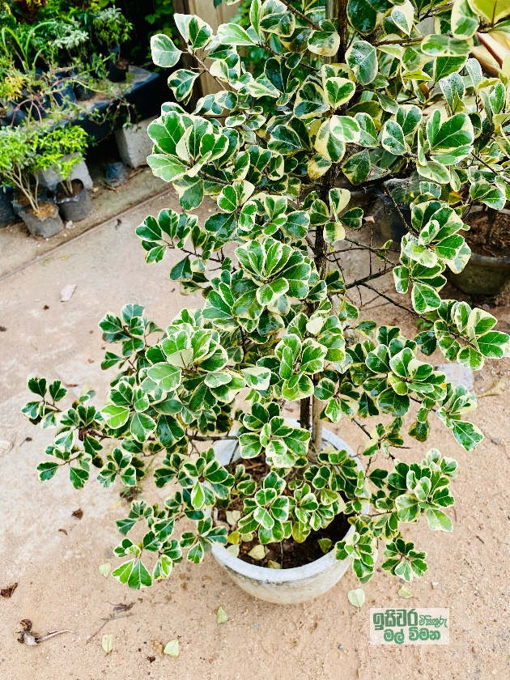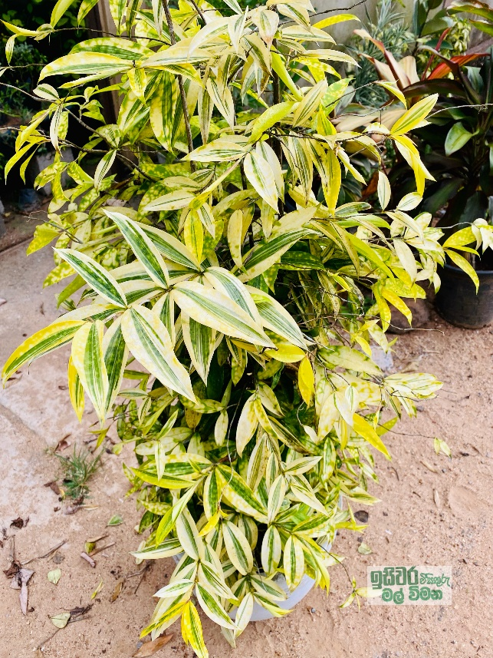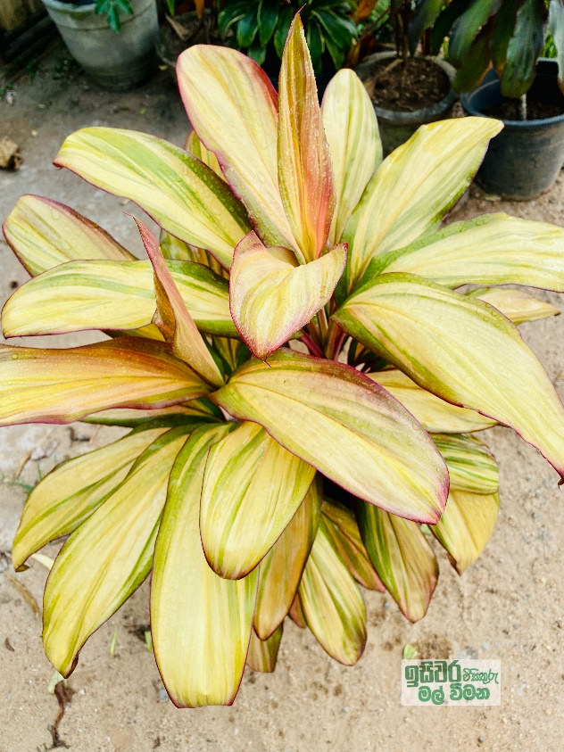

Name: Etisalat Plant

Price: Rs.3500/-

Price: Rs.1000/-

Price: Rs.1000/-

Name: Code-line

Price: Rs.2300/-